## File Hierarchy

The Unix file system is organized as a hierarchy with the root (/) at the highest level from which directories and files may exist. Typically, some of the directories that may occur under the root are *usr, bin, sbin, home, var, boot, dev, etc,* etc. In the figure shown below, *user1* and *user2* are sub-directories under home. hello.txt is a plain-text file and *link_hello* is a linking file that points to hello.txt. In order to access the file */test/temp/hello.txt*, the system begins its search from the root(/) folder and then to test and temp folders consecutively and then finally the file *hello.txt*.

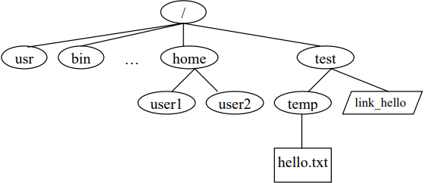

## Ownership and Permissions

Ownership of files in UNIX can be viewed in one of three ways: owner (creator), group or others. Using this simple notion of ownership access to files can be controlled associating unique user ID (UID) and group ID (GID) with twelve permission bits for each file. Typically these bits are divided into three sets of three bits and three extra bits as shown in table below. P

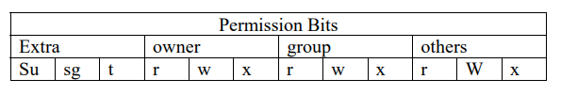

r, w and x bits stand for read, write and execute bits for each of the owner, group and others permissions. su, sg and t stand for set_user_id, set_group_id and sticky bits. These 4 sets of bits are often represented in their octal digits. For example, “100 111 101 101” is represented as “4755.” When the su bit is set, whosoever executes the file, the UID of the process will be the owner of the file. Similarly, if sg is set, the GID of the process will be the owner of the file.

## 1. Setting up user space

1. Login as root

2. Create 2 users, student1 and student2 to the group users

3. Create a file Hello in the student2’s home directory

4. Use the command “ls” to answer **who is the owner and what is the group of the file Hello?**

5. Change group of the file Hello to users and change the owner of the file Hello to student2.

6. Use the command “ls” to answer **who is the owner and what is the group of the file Hello?**

## 2. File and folder permissions

The objective of the following exercises is to see the differences between file and folder (directory) permissions. The chmod command will be used to change file and directory permission to demonstrate the slight differences in permissions for files and directories.

1. Login as root

2. **What are the directory permissions for student1’s, and student2’s home directories?**

3. Login as student1

4. **Can you list the student2’s home directory?**

5. **Can you change the working directory to the student2’s home directory?**

6. Switch user to root

7. Change the permission of student2’s home directory to 740

8. Switch user to student1. **Can you list or change to the student2’s home directory?**

9. Switch user to root

10 Change the permission of student2’s home directory to 750

11. Switch user to student1. **Can you list or change to the student2’s home directory?**

12. **Can you create a new file, Hello2, in the student2’s home directory?**

13. Switch user to root

14. Change the permission of student2’s home directory to 770

15. Switch user to student1. **Can you create a new file, Hello2, in the student2’s home directory?**

16. **What does it mean if the folder permission is 764?**

## 3. Permission of a symbolic link file

Unix supports two kinds of link files--a hard link and a symbolic link. A hard link is a file with the actual address space of some ordinary file's data blocks. A symbolic link is just a reference to another file. It contains the pathname to some other file. (It’s a sort of shortcut to access a file)

1. Login as root

2. Create “home/test/temp” directory

3. In the “home/test/temp” directory, create a new file named source

4. Create a link file named link_source in the “/home/test” directory pointing to the source in the “/test/temp” directory by using the command “ln –s /home/test/temp/source /home/test/link_source”

5. **What are the file permissions of the link_source and source?**

6. **What is the information inside the file link_source?**

## 4. Default file permission

Whenever a new file is created a default set of permissions can be assigned to it. Whatever the permissions are, the UNIX system allows the user to filter out unwanted permissions set by default. This default setting can be set by the user using the umask command. The command takes the permissions set during creation of file and performs a bitwise AND to the bitwise negation of mask value. Some common umask values are 077 (only user has permissions), 022 (only owner can write), 002 (only owner and group members can write), etc.

1. Login as root

2. Use the command “umask -S” or the man page to learn how to use the command umask

3. **What is the current mask? How is it interpreted?**

4. Create a file named testmask1 in the “/test” directory. **What are the permissions of the file testmask1? (hint: ls)**

5. Change the mask to 0077 (current directory), then create a new file named testmask2.

6. **What are the permissions of the file testmask2?**

7. **What is the effect of setting mask value to 0000?**

8. Change the mask back to what you noted in #3

## 5. Setuid Bit

As explained in the ownership and permission section, the highest three bits of the permission value of a file represent the setuid bit, setgid bit and the sticky bit. If the setuid bit is set then the uid will always be set to the owner of the file during execution. If the setuid bit is not set then the uid will be the user who executes the process. Similarly, if the setgid bit is set then the gid will be set to the group that owns the file during execution. If the setgid bit is not set then the gid will be the group that executes the process. The sticky bit is set to keep processes in the main memory.

1. Login as root

2. Use the command “which touch“ to find the path to touch command

3. **What are the permissions of touch?**

4. Change touch’s permissions to 4755

5. Change the permissions of file Hello in the student2’s home directory to 700

6. **What are the permissions and timestamp of the file Hello? (hint: ls)**

7. Switch to student1

8. Use the command “touch” to the file Hello. **What is the file Hello’s timestamp?**

9. Switch to root

10. Change the touch’s permissions to 0755

11. Switch to student1

12. Use the command “touch” to the file Hello. **Why is permission denied? Why is it possible to do in the #7?**

Submit your work by **1:45PM** : https://forms.gle/77yjLwh8CbbdFBks7